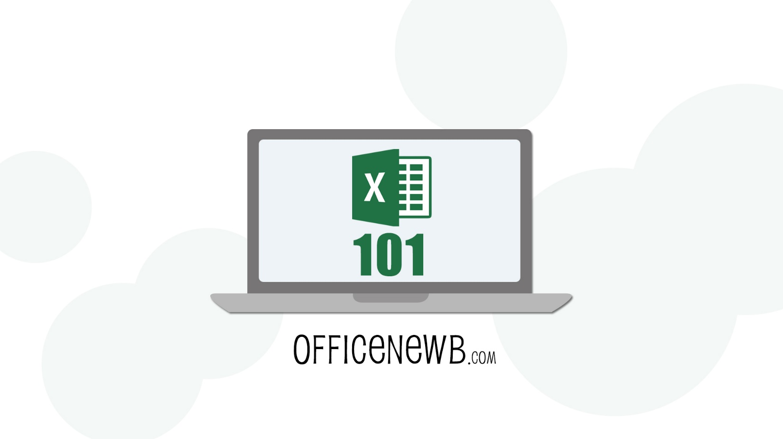

**Microsoft Excel 101 – Introduction to Excel  
Excel Shortcut Keys**

**Author: Kyle Pew (Microsoft Certified Trainer – MCT)**

**Course Reviews**

 *“This is a great course. I love how the lessons are only about 4 minutes each.* ***It makes it possible to learn a lot in a short amount of time.*** *It seems targeted to new learners but it also makes for a great review even if you are familiar with Microsoft Office… 5 stars!” - Wendy*

 *“Great visual over the shoulder presentations by a very articulate instructor. The simple tips on Word and PowerPoint alone were well worth taking the course. What I learned will not only save time, but will end much of the frustration I have experienced with PDF's. Recommend the course.” – Bill*

*“These presentations are very well put together.* ***The instructor keeps you engaged and is easy to follow.****” - Karen*

Contents

Excel Shortcut Keys 3

Instructor BIO: 5

Excel Shortcut Keys

|  |  |
| --- | --- |
| Key | Description |
| Ctrl+PgDn | Switches between worksheet tabs, from left-to-right. |
| Ctrl+PgUp | Switches between worksheet tabs, from right-to-left. |
| Ctrl+Shift+& | Applies the outline border to the selected cells. |
| Ctrl+Shift_ | Removes the outline border from the selected cells. |
| Ctrl+Shift+~ | Applies the General number format. |
| Ctrl+Shift+$ | Applies the Currency format with two decimal places (negative numbers in parentheses). |
| Ctrl+Shift+% | Applies the Percentage format with no decimal places. |
| Ctrl+Shift+^ | Applies the Scientific number format with two decimal places. |
| Ctrl+Shift+# | Applies the Date format with the day, month, and year. |
| Ctrl+Shift+@ | Applies the Time format with the hour and minute, and AM or PM. |
| Ctrl+Shift+! | Applies the Number format with two decimal places, thousands separator, and minus sign (-) for negative values. |
| Ctrl+Shift+* | Selects the current region around the active cell (the data area enclosed by blank rows and blank columns).  In a PivotTable, it selects the entire PivotTable report. |
| Ctrl+Shift+: | Enters the current time. |
| Ctrl+Shift+" | Copies the value from the cell above the active cell into the cell or the Formula Bar. |
| Ctrl+Shift+Plus (+) | Displays the **Insert** dialog box to insert blank cells. |
| Ctrl+Minus (-) | Displays the **Delete** dialog box to delete the selected cells. |
| Ctrl+; | Enters the current date. |
| Ctrl+` | Alternates between displaying cell values and displaying formulas in the worksheet. |
| Ctrl+' | Copies a formula from the cell above the active cell into the cell or the Formula Bar. |
| Ctrl+1 | Displays the **Format Cells** dialog box. |
| Ctrl+2 | Applies or removes bold formatting. |
| Ctrl+3 | Applies or removes italic formatting. |
| Ctrl+4 | Applies or removes underlining. |
| Ctrl+5 | Applies or removes strikethrough. |
| Ctrl+6 | Alternates between hiding and displaying objects. |
| Ctrl+8 | Displays or hides the outline symbols. |
| Ctrl+9 | Hides the selected rows. |
| Ctrl+0 | Hides the selected columns. |
| Ctrl+A | Selects the entire worksheet.  If the worksheet contains data, Ctrl+A selects the current region. Pressing Ctrl+A a second time selects the entire worksheet.  When the insertion point is to the right of a function name in a formula, displays the **Function Arguments** dialog box.  Ctrl+Shift+A inserts the argument names and parentheses when the insertion point is to the right of a function name in a formula. |
| Ctrl+B | Applies or removes bold formatting. |
| Ctrl+C | Copies the selected cells. |
| Ctrl+D | Uses the **Fill Down** command to copy the contents and format of the topmost cell of a selected range into the cells below. |
| Ctrl+E | Adds more values to the active column by using data surrounding that column. |
| Ctrl+F | Displays the **Find and Replace** dialog box, with the **Find** tab selected.  Shift+F5 also displays this tab, while Shift+F4 repeats the last **Find** action.  Ctrl+Shift+F opens the **Format Cells** dialog box with the **Font** tab selected. |
| Ctrl+G | Displays the **Go To** dialog box.  F5 also displays this dialog box. |
| Ctrl+H | Displays the **Find and Replace** dialog box, with the **Replace** tab selected. |
| Ctrl+I | Applies or removes italic formatting. |
| Ctrl+K | Displays the **Insert Hyperlink** dialog box for new hyperlinks or the **Edit Hyperlink** dialog box for selected existing hyperlinks. |
| Ctrl+L | Displays the **Create Table** dialog box. |
| Ctrl+N | Creates a new, blank workbook. |
| Ctrl+O | Displays the **Open** dialog box to open or find a file.  Ctrl+Shift+O selects all cells that contain comments. |
| Ctrl+P | Displays the **Print** tab in Microsoft Office Backstage view.  Ctrl+Shift+P opens the **Format Cells** dialog box with the **Font** tab selected. |
| Ctrl+Q | Displays the **Quick Analysis** options for your data when you have cells that contain that data selected. |
| Ctrl+R | Uses the **Fill Right** command to copy the contents and format of the leftmost cell of a selected range into the cells to the right. |
| Ctrl+S | Saves the active file with its current file name, location, and file format. |
| Ctrl+T | Displays the **Create Table** dialog box. |
| Ctrl+U | Applies or removes underlining.  Ctrl+Shift+U switches between expanding and collapsing of the formula bar. |
| Ctrl+V | Inserts the contents of the Clipboard at the insertion point and replaces any selection. Available only after you have cut or copied an object, text, or cell contents.  Ctrl+Alt+V displays the **Paste Special** dialog box. Available only after you have cut or copied an object, text, or cell contents on a worksheet or in another program. |
| Ctrl+W | Closes the selected workbook window. |
| Ctrl+X | Cuts the selected cells. |
| Ctrl+Y | Repeats the last command or action, if possible. |
| Ctrl+Z | Uses the **Undo** command to reverse the last command or to delete the last entry that you typed. |

Instructor BIO:

Kyle is a Microsoft Certified Trainer (MCT) and a certified Microsoft Office Master Instructor and has been teaching and consulting for the past 10+ years on various computer applications, including;

1. Microsoft Office Suite 1997, 2000, XP, 2003, 2007, 2010, 2013
   1. Excel, Word, PowerPoint, Outlook, Access and Visio
2. SharePoint End-User 2007, 2010, 2013
3. VBA (Excel and Access)
4. Adobe Suite
   1. Photoshop, Illustrator, InDesign
5. Maya (Modeling and Animation)
6. Unity3d (Game Design)
7. HTML, CSS and JavaScript
8. Crystal Reports

Kyle is a graduate of the San Francisco Art Institute in the Media Arts and Animation Program. He has worked as a Game Designer for Electronic Arts, designing on games such as Nerf N-Strike, Nerf N-Strike Elite, both for the Wii, and a Sims 3 Expansion Pack for the PC.

Kyle has facilitated courses that range from 1-on-1 interactions to large scale groups of 100+ participants, including; live in person classes, webinar style classes online and live online full courses. He is consistently ranked top in reviews for each of the courses he teaches.

**What Students have said about Kyle:**

* ***"Kyle was off the chart "GOOD""***
* ***"ONE OF THE BEST COURSES THAT I'VE HAD... (IN 12+ YEARS)."***
* ***"Awesome trainer because I'm computer "stupid" and he helped me understand it."***
* ***"Kyle Pew is very knowledgeable and presented information with exceptional skill."***

In his 10+ years of training (corporate training, 1-on-1 consulting and college courses), Kyle has taught 1000's of courses and 10's of thousands of students all the while maintaining a high level of delivery and satisfaction from the student he has taught.

**Teaching Philosophy:**

Kyle believes that student’s best learn through the application of real-life business situations through exercises. Allowing students to guide the class with their specific situations allows for the quickest and easiest adaptation to new technology and skills.

**Check out my Udemy profile for more information and more courses.**  
<https://www.udemy.com/user/kyle-pew/>